Juan Villegas

MAT 342 – Explorations in Data Science
HW 05: C5.0 Models
Questions:
- How does C5.0 differ from CART in how it decides to split the data?
C5.0 differs from CART because it uses entropy to split data compared to CART using gini index. What c5.0 does is: it finds the mean information requirement which it then uses to find the information gain. The splits are decided from the largest information gain with respect to the target variable
- How does C5.0 differ from CART in how many branches may descend from a decision node?
C5.0 can have multiple splitting branches compared to CART’s binary split. C5.0 can have one or more branches meaning that the decision tree will look “bushier”.

Open the zoo.csv data set in R.
Prelude: Run the following code to remove the animal names, recode the target variable class_type into its categorical values, and make the target variable a factor.
d <- d[,-1] levels(d$class_type) <- c("Mammal", "Bird", "Reptile", "Fish", "Amphibian", "Bug", "Invertebrate") d$class_type <- as.factor(d$class_type)

- Make a table of the target variable. The baseline model classifies all values as the category with a plurality – e.g. the largest category. What is the baseline model for this data set? What is the accuracy of that baseline model?
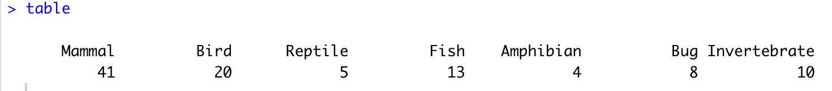
The baseline model for this data is ‘Mammal’. The accuracy of this baseline model is: (41/(41+20+5+13+4+8+10)) = 0.4059406 or 40.59%

- Partition the data into 75% Training and 25% Test data. Validate the partition on three variables of your choice.
I Chose to validate ‘Aquatic’, ‘Milk’, and ‘Predator’. The box plots for all of them have filled boxplots (so they look the same) and the p-values are all over .1 which means this partition can be validated.
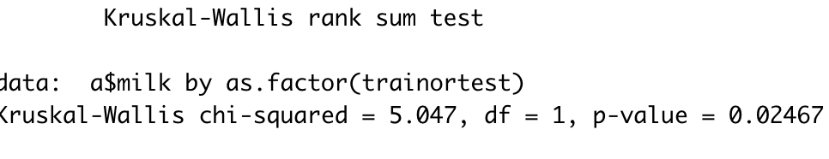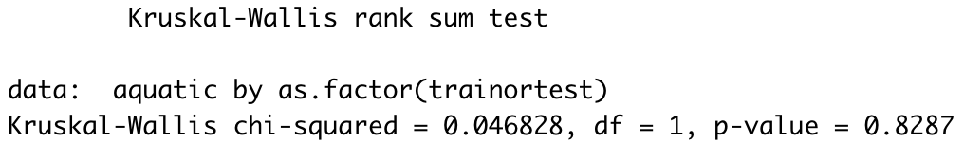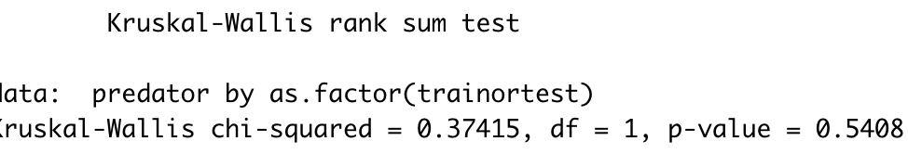

- Create a C5.0 model (10-fold cross validation optional) to classify class_type based on the other variables. Report the decision rules uncovered by the model, and what percent of the data each rule applies to.
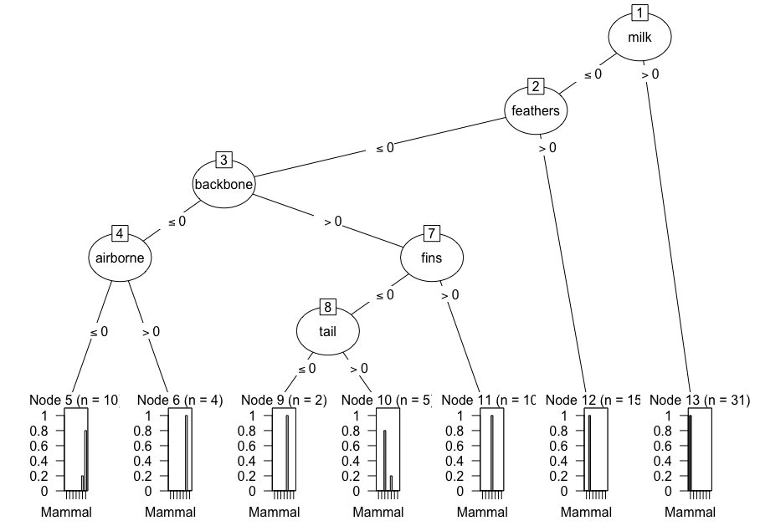
The C5.0 Model shows that if you have milk then you are (100%) a mammal. If you don’t have milk, and you have feathers, then you are (100%) a bird. If you don’t have milk or feathers, then you can have a backbone. If you have a backbone, you can have one of two things: fins or a tail. If you have fins, then you are (100%) a fish. If you have a tail, there’s an 80% chance you’re a reptile. If you have a backbone but no tail, then you are (100%) an Amphibian. If you have no backbone, then you can airborne and be classified as a bug. If you have no backbone and are not airborne then there’s an 80% chance of you are an invertebrate
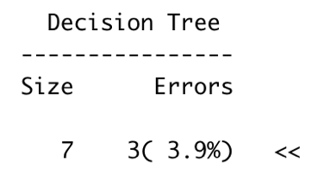
- What is the accuracy of the C5.0 model on the Training data? By how much did the C5.0 model improve classification accuracy over the baseline model?
According to the data using the summary command, I can understand that the accuracy of the C5.0 model on the Training data is 96.10% (1-.039). The model improved classification accuracy over the baseline model 55.51% (96.10-40.59).

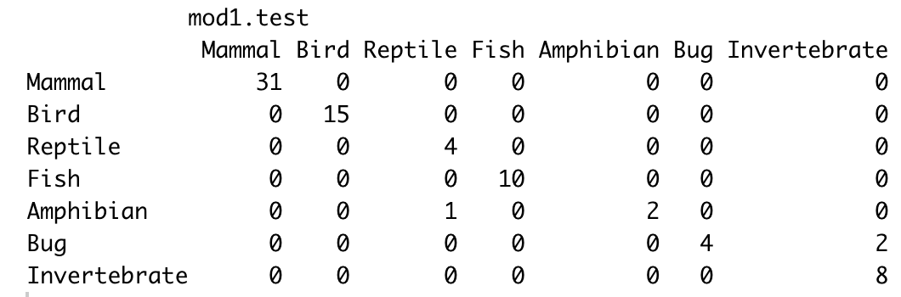
- Evaluate the model by obtaining the accuracy of classifications made on the Test data set. What is the accuracy? How does it compare to the accuracy of the model on the Training data?
(31+15+4+10+2+4+8)/77 = 0.961039. which is 96.10%
The test data set is 96.10% accurate. Comparing this to the Training data set is strange because the measures are the same which means the model has a good and consistent performance… Or I might have the change the seed hahaha.

